**CHICKEN STEW**

Ingredients

500 g chicken wings and legs  
one onion ;  
300 g green peppers

2 cloves of garlic

a little parsley;

200 g tomatoes

75 ml oil  
10 g thyme;  
300 ml tomato paste  
5 g pepper;  
salt and pepper;

Method

We wash the chicken meat and slice it  
 We peel and slice the onion and the green peppers  
 We scald and then slice the tomatoes   
 We peel the garlic ;  
 Heat the oil and stir fry the onion and the green peppers

We add tomatoes and the meat .They simmer together until forming a sauce.   
 We add green chopped parsley ;  
 We put the vegetables and the meat in a bowl and add garlic sauce.

Additionally, if you want, add pepper , thyme , spices and put the bowl in the oven for 15 minutes at a low heat

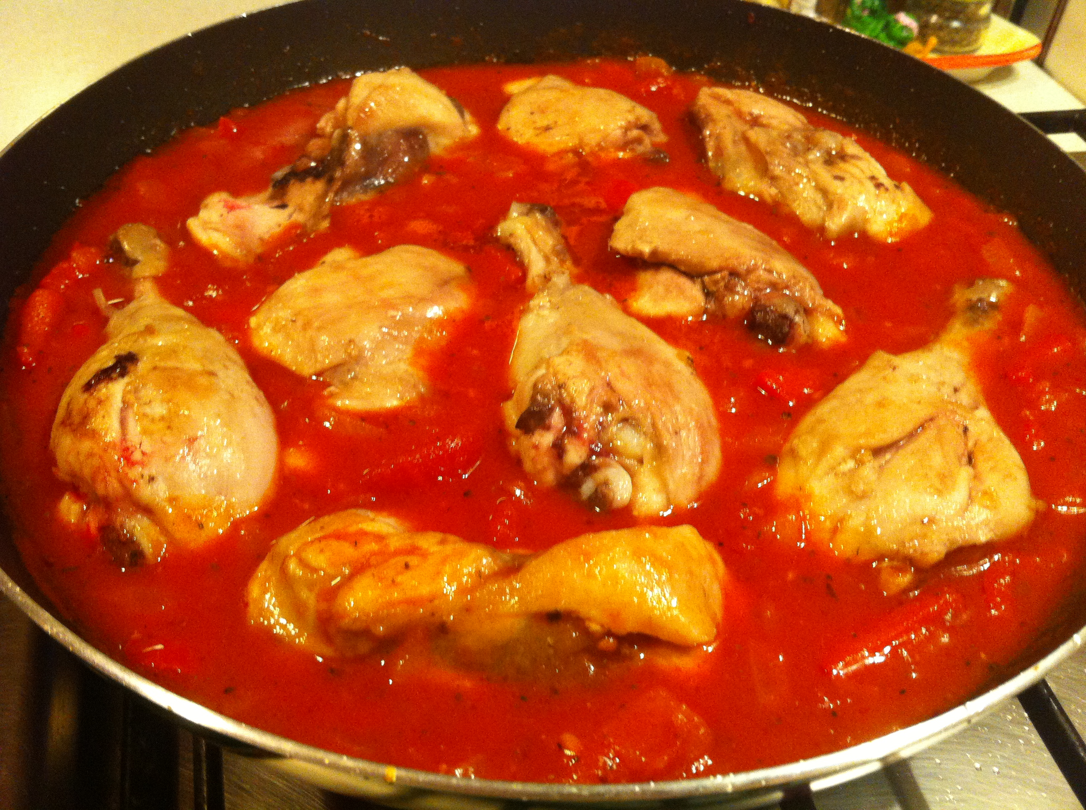

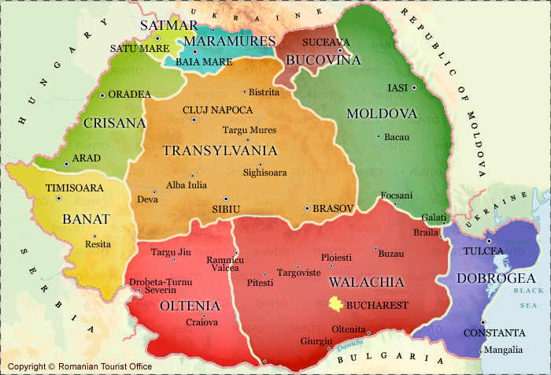of recipe origins

**TRANSYLVANIAN PORK STEAK**

Ingredients

600 g pork  
4 smoke-dried pork sausages  
2 big onions   
5 cloves of garlic  
150 g tomato sauce

150 ml water

salt  
pepper  
fresh parsley

Method

1: We cut the pork sausages in little pieces, and fry them for 5 min.  
2: We add the pork and fry it  
3: After frying, we take it out and we stir-fry the onion and the garlic.  
4: Over the garlic and the onion, we put the pork sausages, the pork, the water and the tomato sauce.   
5: We leave it to boil.   
6: After a few minutes, we put it on a plate, and we add salt, pepper and some fresh parsley.   
7: We can serve it with fried eggs.  
8: Enjoy it!

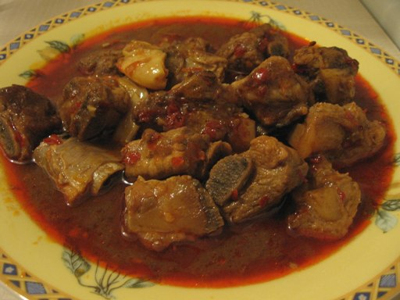



**PASCAL CAKE**

Ingredients

1 kilo of flour   
3 eggs  
2 g dry yeast  
300 ml milk

2 spoonful oil

Salt

Method

We pour little milk in a metal cup and leave it to boil, add 2 spoonful of flour and stir so that it won’t form lumps. Let it cool.

Put the remaining flour in a metallic vessel , sprinkle 1-2 spoonful of salt , put yeast and mix. Then add milk and 2 eggs and start kneading for about 15-20 minutes. Leave the dough powdered with some floor at hot place , about aprox. 1 hour and 30 minutes, to increase .

Keep 1/3 of the dough for decorating. Shape the rest into a round loaf and place in a greased round pan, then shape the reserved dough into decorations of choice. Cover the pan with greased plastic wrap and let rise until almost doubled.

Take an yolk of egg and grease the pascal cake . Put it in the oven , at medium heat, until golden brown .

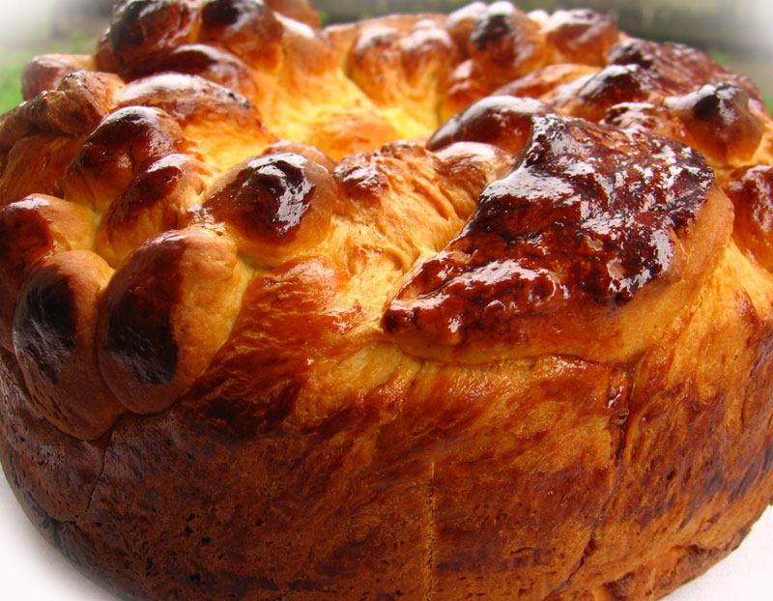

cipe origins

**BORSCH WITH SOUR CREAM**

Ingredients

8 small potatoes

4 carrots

2 onions

1 small celery

2 peppers

peas 100 grams

250 grams sour cream

3 tablespoons oil

salt and pepper

Method

We wash vegetables and peel onions and peppers.

We chop them and grate celery and the carrots .

In a pot , put oil and cook until vegetables soften.

Add 4 litres of water and let it simmer for 20 minute.

We add potatoes and let simmer for 15 minutes, then add the peas and boil for 5 minutes more.

Try if the potatoes are cooked , add salt, pepper and cream and let it boil for little time.

Serve hot with croutons.

Optionally, you can serve it soured with lemon juice





**SHEPARD’S POLENTA BALLS**

Ingredients

250 corn flour

500 ml water

300 g sheep telemea (white cheese)

500 ml milk

100 g butter

1 teaspoon of salt

Method

1. Boil the water with the milk, salt and a table spoon of butter. When the water boils put the corn flour gradually, mixing constantly until it is thick.   
  
2. With a table spoon place the polenta on to a thermo resistent tray greased with a lot of butter and put a table spoon of grated telemea on top of each piece of polenta. Then shape the pieces as bowls using the spoon.  
  
3. Place a bit of butter on top and put the tray in the oven for 15 minutes, then serve immediately.

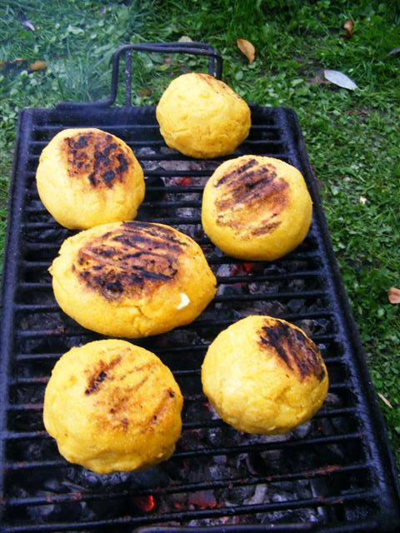



**COTTAGE CHEESE PIE**

Ingredients

*Dough* 300 g white flour

200 g Butter B

100 ml cold water

1 spoon vinegar

½ teaspoon of salt

Filling: 500 ml youghurt, 200g soft cheese, 100g melted butter, 8 eggs, 10 tbsp sugar, 3 sachets of vanilla sugar, 50 g raisins in rum

Method

1. Mix in the flower, salt and cold butter until it turns into a sandy dough.  Add the vinegar and gradually the cold water. Incorporating until the dough becomes homogeneous. Leave it in the refrigerator for about 30 minutes and then spread it into thin layers. Cut the layers at the dimension desired for the pie.   
  
2. Mix the eggs with the sugar and vanilla sugar and incorporate the cottage cheese and yoghurt gradually.  
  
3. In a rectangular tray, place special baking paper and put 3-4 pie sheets one on top of the other, after greasing them with melted butter. Poor into them the filling and cover with other 3-4 sheets. Put the tray into the oven heated 45 minutes before, medium temperature. Serve warm.

