Spain is a diverse country sharing the Iberian Peninsula with Portugal at the western end of the Mediterranean Sea. It is the country with the second-largest number of UNESCO World Heritage Sites, after Italy, and the largest number of World Heritage Cities.
Spain is considered an exotic country in Europe due to its friendly inhabitants, relaxed lifestyle, its cuisine, vibrant nightlife, and world-famous folklore and festivities. Among many places worth visiting are Spain's thriving capital Madrid, the vibrant coastal city of Barcelona, the famous "Running of the Bulls" at Pamplona, major Andalusian cities with Islamic architecture, like Seville, Granada and Córdoba, the Way of St. James and the idyllic Balearic and Canary Islands.
Once the center of a global empire with territories in North, Central and South America, Africa (e.g. Equatorial Guinea or Western Sahara), and Asia (e.g. the Philippines), contemporary Spain has overcome civil war and fascism in the 20th century to stand proud and centered in itself.
One of their greatest prides is the national football team. They are currently ranked number 7 in the FIFA Rankings and 5th in the Elo Rankings. They have the fourth all-time highest ratings with 2142, and have been considered one of the strongest teams in world football ever since the mid to late 1960s.
Spain are one of eight national teams to have been crowned World Cup champions. Having done so in the 2010 FIFA World Cup that was held in South Africa. Defeating the Netherlands 1-0 to claim their very first title, and with it becoming the first European team to win it outside of Europe. They are currently the reigning European champions, having won back to back titles in both Euro 2008 and Euro 2012, defeating Germany in 2008 and Italy in 2012. These three titles won in successive matter make them the only national team so far with three consecutive wins of either the applicable continental championship or the World Cup. From 2008 to 2013 (6 years) the national team won FIFA Team Of The Year. The second most only behind Brazil who won it on 7 straight years.^{[6]} Between November 2006 and June 2009 Spain went undefeated for a record-equalling 35 consecutive matches before their loss to the United States, a record shared with Brazil.^{[7]} The team's achievements have led many commentators, experts and former players to consider the 2010 and 2012 Spanish sides among the best ever international sides in world football.
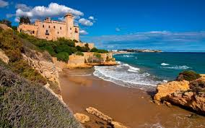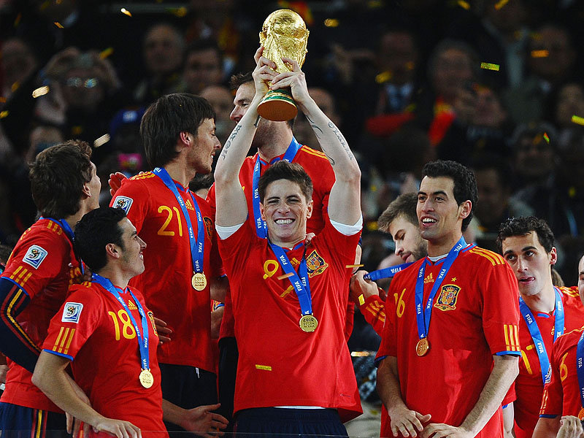

Ecuador is a country in Northwestern South America, with a Pacific Ocean coastline, lying on the Equator between Colombia, to the northeast, and Peru, to the south and east.
Cotopaxi is the world's highest active volcano. Many cities and sites in Ecuador are listed as UNESCO World Heritage Sites. Such cities and best known places are the Galapagos Islands, and the city of Cuenca.
The "Republic of the Ecuador" was one of three countries that emerged from the collapse of Gran Colombia in 1830 (the others being Colombia and Venezuela). Between 1904 and 1942, Ecuador lost territories in a series of conflicts with its neighbors. A border war with Peru that flared in 1995 was resolved in 1999.

The largest mega-diversity on the planet makes it home in Ecuador, the center of the world. With a privileged climate and the most breathtaking landscapes, the essence of Latin America merged to create a unique and unforgettable destination. Islands, rainforest, Andes and seas, 4 worlds are waiting for you.
The Ecuadorian national football team represents Ecuador in international football competitions and is controlled by the Ecuadorian Football Federation (Federación Ecuatoriana de Fútbol). They play official home matches at Estadio Olímpico Atahualpa in Quito.
Ecuador has qualified for three FIFA World Cups in 2002, 2006 and 2014. Their best performance came in 2006 when they advanced to the Round of 16, eventually eliminated by England. They are one of three countries in South America not to have won the Copa América, the others being Chile and Venezuela. Their best performance in the continental tournament was fourth in 1959 and 1993, both times on home soil.
